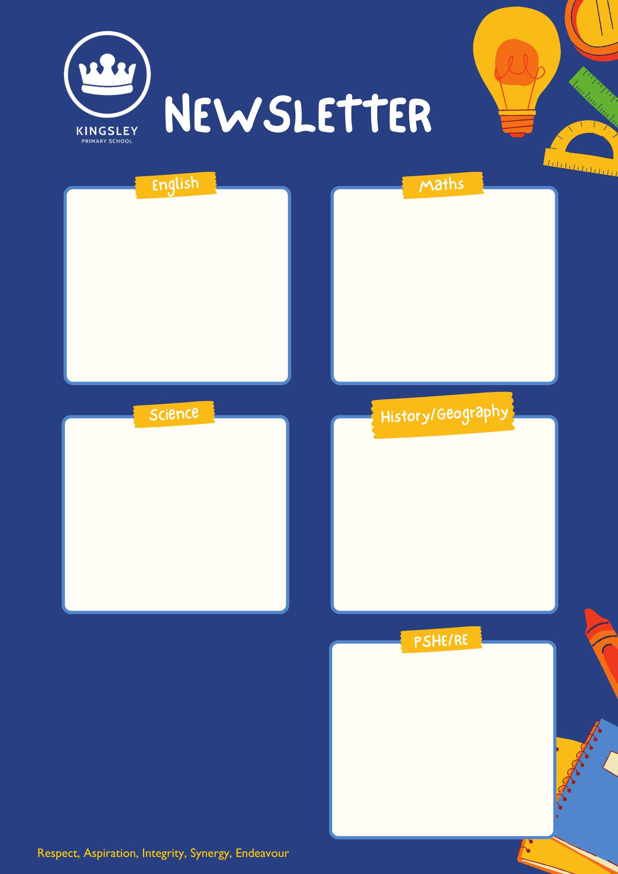
YEAR 6 – Spring Term 1

This half term, our focus is Keeping Safe. Children will learn about making safe choices in different situations, understanding risks, and knowing who to turn to for help. We’ll also discuss strategies for staying safe online and in the community.
[Grab your reader’s attention with a great quote from the document or use this space to emphasise a key point. To place this text box anywhere on the page, just drag it.]
This half term, we’ll be exploring Why Does Population Change? Children will learn about the factors that affect population growth and decline, such as birth rates, migration, and resources. We’ll also look at how these changes impact communities around the world.
This half term, our topic is Light. Children will investigate how light travels, how shadows are formed, and how we see things. They’ll carry out experiments to explore reflection and refraction, developing their understanding through hands-on activities.
This half term, we’ll be tackling exciting challenges in ratio, algebra, and measure. Children will learn how to compare quantities, use letters to represent numbers, and apply their skills to real-life problems involving length, weight, and capacity.
This half term, we’ll be reading Can You See Me? by Libby Scott and Rebecca Westcott. Children will explore themes from the story and use them to inspire their own writing. We’ll be creating a narrative and an explanation text, focusing on developing descriptive language and clear structure
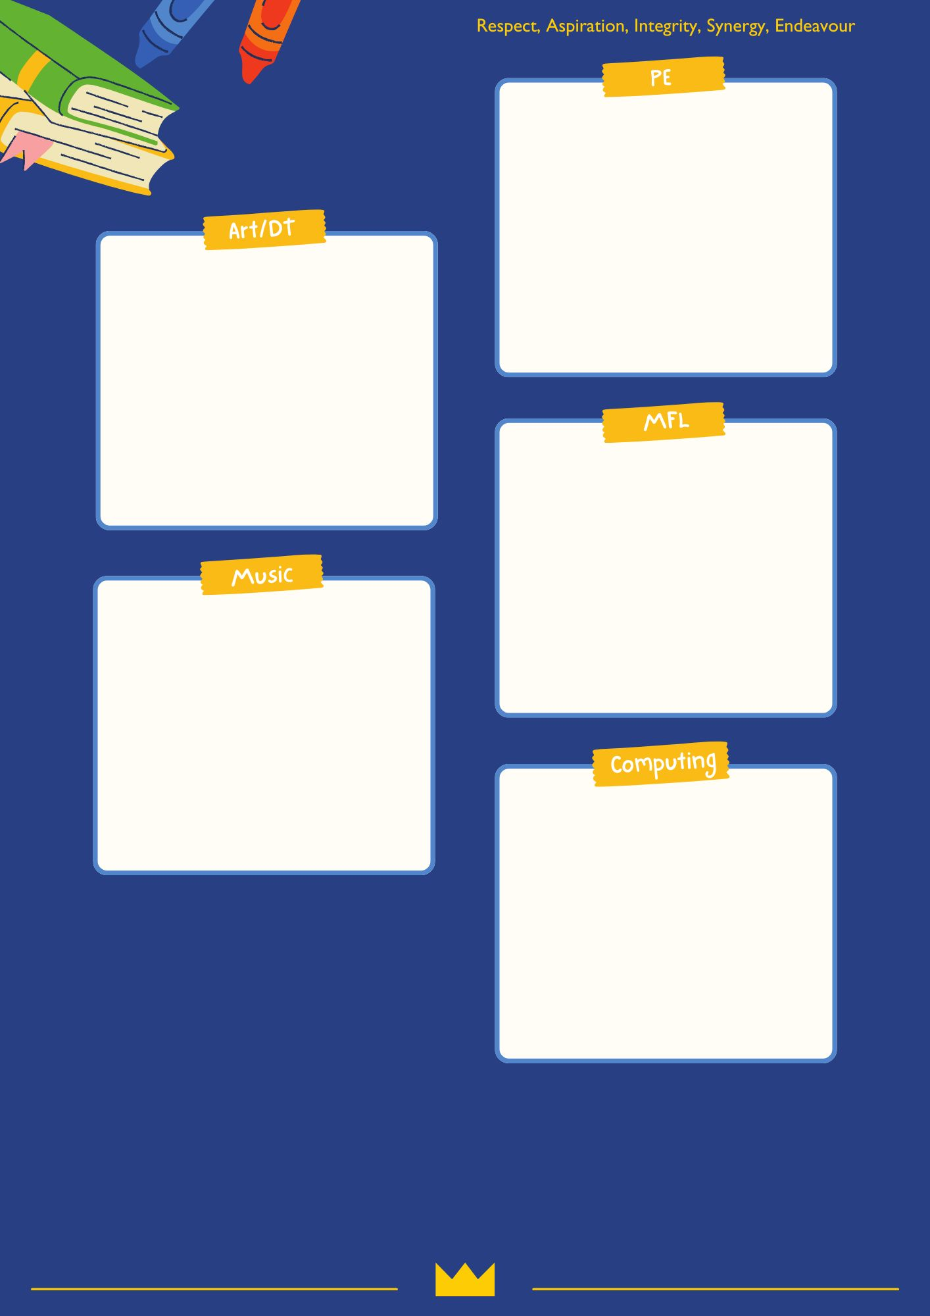
This term, we’ll be developing strength, balance, and flexibility through exciting gymnastics activities. We’ll also learn invasion games, where children will practice teamwork, communication, and strategic thinking while having fun and staying active!
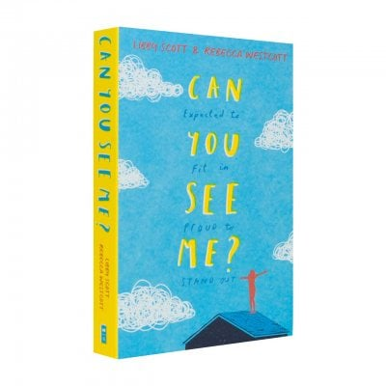
This half term, we’ll be exploring variables in programming through fun, interactive games in Scratch. Children will learn how variables work and use them to create their own simple program
This half term, our learning will focus on one beautiful piece: “A New Year Carol” from Benjamin Britten’s Friday Afternoons. Children will explore the melody, lyrics, and meaning of the song, and develop their singing and listening skills through practice and performance.
This half term, we’ll be learning how to say what we are able to do using the phrase “Je peux…”. Children will practice talking about activities they can do and build simple sentences to express their abilities.
This half term, our unit is Digital World: Navigating the World. Children will explore how technology helps us find our way, learning about navigation systems and designing their own digital solutions.

