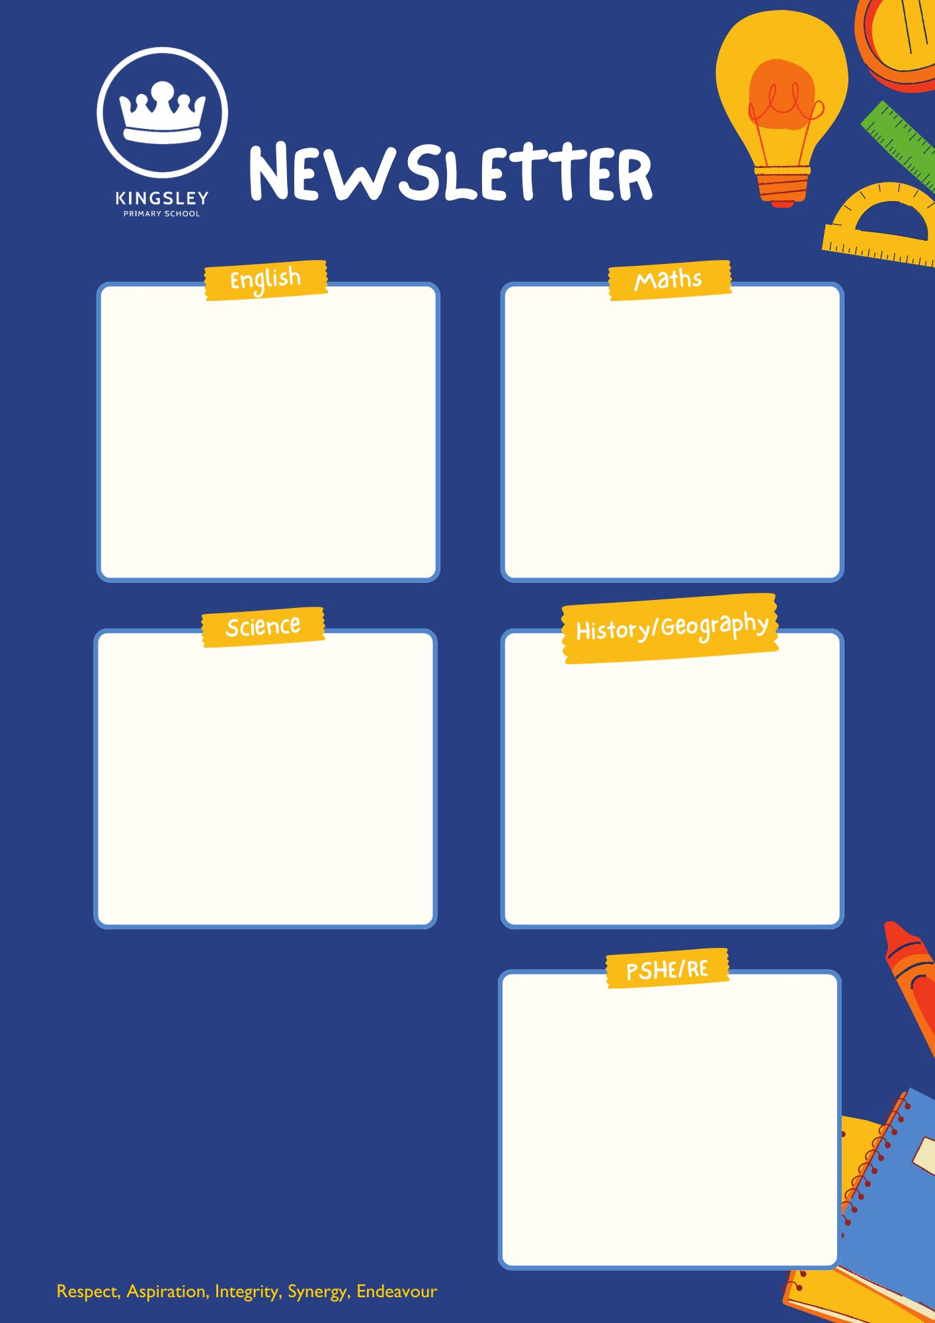
YEAR 6 – AUTUMN TERM 1

In PSHE our unit for the term is called Me and My Relationships and focusses on building and sustaining positive relationships with others. We also explore ways in which to negotiate tricky situations which can arise both with friends and others.

[Grab your reader’s attention with a great quote from the document or use this space to emphasise a key point. To place this text box anywhere on the page, just drag it.]
Our History topic this term will be the Victorians, in particular Anthony and why he is considered one of the most influential figures of the period.
Our Science topic for this term will be Evolution and inheritance. We will be examining the different ways in which animals are adapted to their unique environments and how evolution has caused this.
In Maths this term, we will be focussing on building strong foundations in number and place value before applying this knowledge to the four operations (Addition, Subtraction, Multiplication and Division)
This term we will be focussing on the beloved children’s book Holes by Louis Sachar in our reading lessons. We will also be using this as a springboard for some of our writing lessons.
“Nothing in life is easy. But that's no reason to give up. you'll be surprised what you can accomplish if you set your mind to it.”
― Louis Sachar, Holes
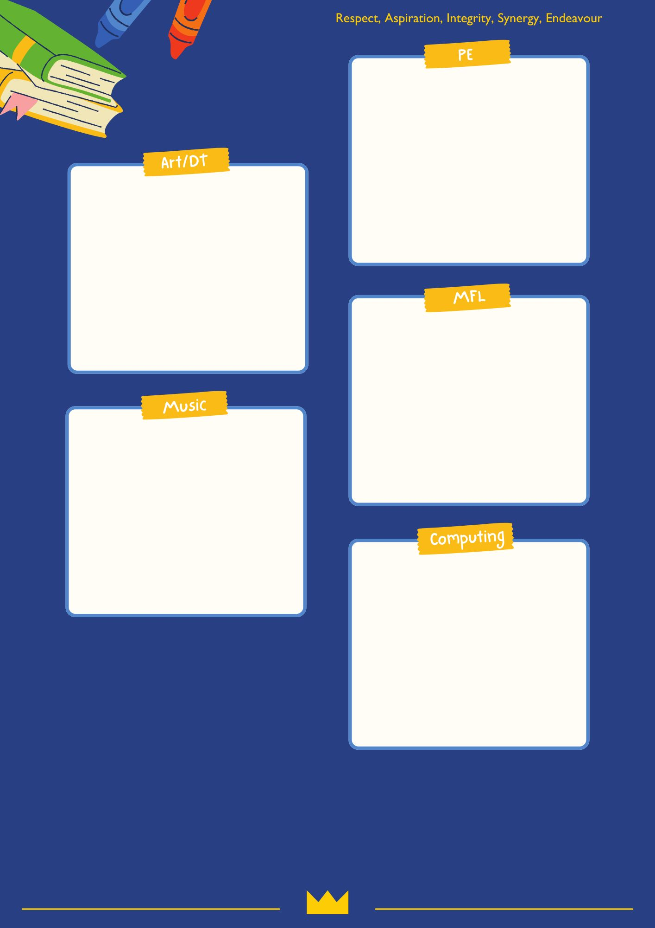
We will be focussing on two sports this term: Tag Rugby and Hockey. During which we will be looking at the tactics involved in team invasion games and how to develop our technical skills.
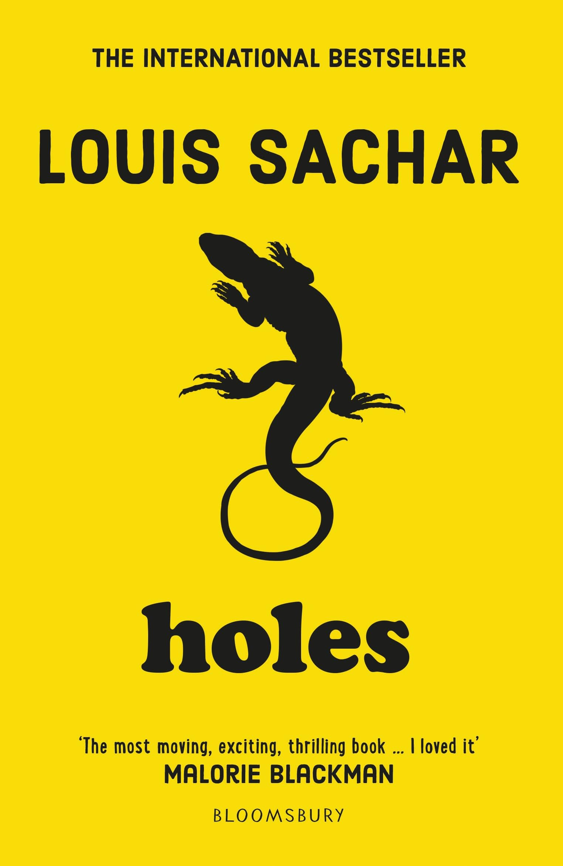
In Computing this term, we will be covering Computing systems and networks - Communication and collaboration. As we explore the unit, we will also be paying particular attention to how to stay safe in an increasingly digital world.
In Music this term, we will be focussing on the unit Music Speaks – Hip Hop. We will becreating and produce music with multiple sections that include repetition and contrasts, and using chord changes as part of a (sequenced) composition.
In French this term, our focus will be La phonétique (Phonics & Pronunciation).
In Art this term, we will be doing sketching and pencil work, with a particular focus on Street art. We will explore the technical side of this artform as well as the messages which it sends and emotions which it evokes.

