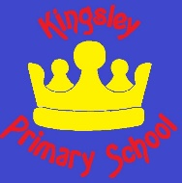
Kingsley Primary School

Pupil premium strategy statement

This statement details our school’s use of pupil premium funding to help improve the attainment of our disadvantaged pupils.
It outlines our pupil premium strategy, how we intend to spend the funding in this academic year and the effect that last year’s spending of pupil premium had within our school.

School overview
Detail | Data
School name | Kingsley Primary School
Number of pupils in school | 411
Proportion (%) of pupil premium eligible pupils | 26%
Academic year/years that our current pupil premium strategy plan covers (3 year plans are recommended) | 2024 - 2027
Date this statement was published | October 2024
Date on which it will be reviewed | September 2025
Statement authorised by | Liam Cox
Pupil premium lead | Scarlet de Sade
Governor / Trustee lead | Minaxi Patel

Funding overview
Detail | Amount
Pupil premium funding allocation this academic year | £127,000
Pupil premium funding carried forward from previous years (enter £0 if not applicable) | £TBA
Total budget for this academic year | £127,000

Part A: Pupil premium strategy plan

Statement of intent

At Kingsley Primary School, we feel it is important to consider the context of the school and the challenges faced by our pupils when deciding how to use the Pupil Premium funding. The decisions will be based on research that indicates approaches enable good levels of progress for the pupils, particularly the research conducted by the Education Endowment Foundation (EEF).

We have found that there are some common barriers to learning for disadvantaged children due to the situations of their families - less support at home, weak language and communication skills, lack of confidence, lack of resilience, more frequent behaviour difficulties and attendance and punctuality issues. There may also be complex family situations that prevent children from flourishing. The challenges are varied and there is no “one size fits all”. It is also acknowledged that this description matches pupils who do not qualify for Pupil Premium funding, and that not all pupils who do qualify are facing these issues. It is our intention to utilise the funding in a way that enables all learners to meet their full potential.

We will ensure that all teaching staff are involved in the analysis of data and identification of pupils, so that they are fully aware of strengths and weaknesses across the school. We will endeavour to involve the staff who know the child best in the decision-making process when discussing which approaches to use in overcoming their barriers to learning.

Principles
- We ensure that teaching and learning opportunities meet the needs of all the pupils
- We ensure that appropriate provision is made for pupils who belong to vulnerable groups, this includes ensuring that the needs of socially disadvantaged pupils are adequately assessed and addressed.
- In making provision for socially disadvantaged pupils, we recognise that not all pupils who receive free school meals will be socially disadvantaged
- We also recognise that not all pupils who are socially disadvantaged are registered or qualify for free school meals. The Pupil Premium funding will be used to support any pupil or groups of pupils the school has legitimately identified as being socially disadvantaged.
- Pupil premium funding will be allocated following a needs analysis which will identify priority classes, groups or individuals. Limited funding and resources mean that not all children receiving free school meals will be in receipt of pupil premium interventions at one time.

Demography and School Context

Kingsley Primary is a two-form entry primary school located in Kingsley, Northampton. The maps below displays the “Lower Super Output Areas” (LSOAs) according to the Consumer Data Research Centre, which surround the school, and they are colour coded according to which national decile they belong to: decile 1 being the most deprived and decile 10 being the least deprived (IMD rankings).

Our catchment area is consistently ranked as within the 30% of areas of most deprivation, and the highest 20% experiencing wider barriers to education, financial and social success.
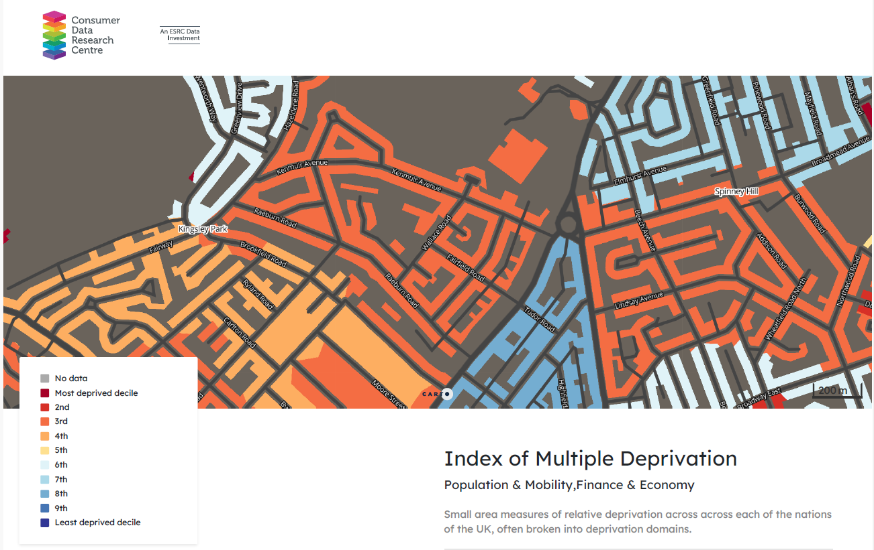
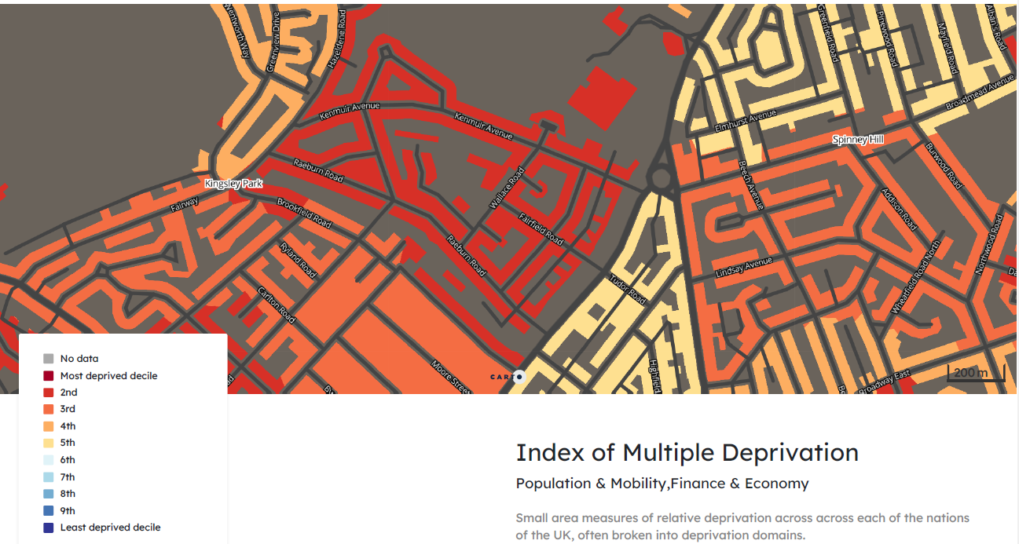

Out of our school of 410 pupils, we currently have 107 pupils for whom we receive Pupil Premium funding. This represents 26% of all pupils on roll, which is above the National average of 23%. We are very aware that we have many other families experiencing long- and short-term difficulties due to the current financial climate, and we are keen to ensure we utilise the Pupil Premium funding to meet the needs of all pupils experiencing the negative effects of deprivation.

Ultimate Objectives
- To narrow the attainment gap between disadvantaged and non-disadvantaged pupils
- For all disadvantaged pupils in school to meet or exceed nationally expected progress rates in order to reach Age Related Expectations by the end of Year 6
- To provide support for the social and emotional development of pupils
- To create high aspirations in our pupils for themselves

Achieving These Objectives
The Education Endowment Foundation’s research provides the basis for our priorities when it comes to deciding how to spend the Pupil Premium funding to meet the objectives for our pupils. It is believed that the highest impact comes from investing in developing and maintaining high-quality teaching. Secondary to this is the provision of targeted interventions for pupils, to fill the gaps in their learning, and then investment in the wider opportunities that these pupils may not otherwise experience.

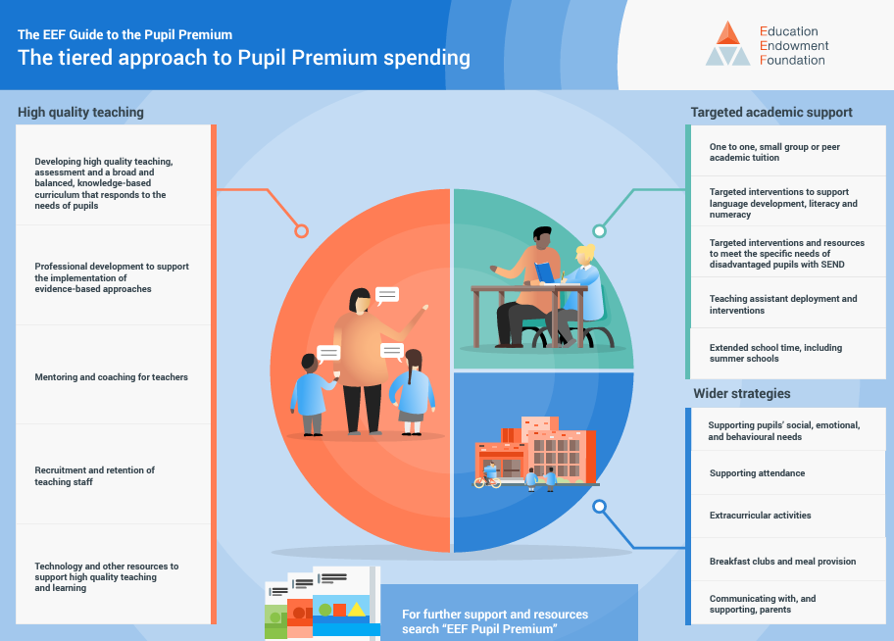

The range of provision the school considers making for this group include: -
- Staff CPD/new programs to ensure good quality first teaching and learning
- Emotional support and learning mentoring through a dedicated staff member
- Payment towards the costs of educational visits and residentials
- Providing enrichment opportunities for pupils to use in their learning
- To develop self-image and to instil high aspirations.
- To improve attendance for PP pupils.

This list is not exhaustive and will change according to the needs and support our socially disadvantaged pupils require.

We will focus on developing our pupils’ understanding of the core curriculum subjects by spending a portion of our funding contributing to the cost of Read, Write, Inc. phonics scheme and training; Grammasaurus writing resources, which include grammar and unit guides for all genres of writing; and Power Maths scheme of work to support pupils in strengthening their fluency and mastery of all maths topics. To create additional opportunities for the pupils to develop their knowledge in the core curriculum subjects in cohesive and engaging ways, we provide pupils with excellent experiences in a variety of ways. These include Notivate, where the pupils in Year 4 spend time over a series of weeks writing their own songs with a professional musician, then they record them in a real recording studio. Their tracks are then mixed and mastered for publishing so that the children can take away their finished product. We find this work incredibly valuable to the children, not just as an opportunity to learn about the roles of the professionals, and as an exciting experience, but as a series of activities which help to develop reading and writing, as well as collaborative working in a real-life setting.

Challenges
This details the key challenges to achievement that we have identified among our disadvantaged pupils.
Challenge number | Detail of challenge
1 | Low attainment in English, particularly in SPaG, for our disadvantaged pupils.
2 | Low attainment in Maths.
3 | High proportion of children eligible for PP funding have ongoing difficulties at home (involvement with Social Services, CIN plans, EHAs, LAC and history of domestic violence, limited support from home) and/or difficulties with resilience and mental health, and therefore require additional support. 80% of pupils/families working with the Family Support/Learning Mentor are PP eligible, compared with 26% of school population being PP eligible.
4 | Low attendance rates for a high number of children eligible for PP funding, including lateness which impacts on learning due to missed/part sessions.
5 | Lack of external wider curriculum opportunities. Pupils from disadvantaged backgrounds are less likely to have aspirational goals for themselves throughout the school, impacting heavily on their futures.

Intended outcomes
This explains the outcomes we are aiming for by the end of our current strategy plan, and how we will measure whether they have been achieved.
Intended outcome | Success criteria
To improve English attainment across the school using PVPG (Grammarsaurus), which will impact upon more PP pupils achieving ARE in English (writing and SPaG) at the end of the year. | Rapid progress in writing and SPaG for PP pupils across the school, evident in book looks, termly data and learning walks.
To improve Maths across the school using  Power Maths, which will impact upon more PP pupils achieving ARE in Maths at the end of the year. | Rapid progress in Maths for PP pupils across the school, evident in book looks, termly data and learning walks.
To improve phonics across EYFS and KS1 using Read, Write Inc., which will impact upon more PP pupils achieving ARE at the end of the year | Rapid progress in phonics for PP pupils across EYFS and KS1, evident in learning walks and data.
Continued improvement in learning attitudes and behaviour of targeted PP children and continued engagement of families. | Data demonstrates that PP children with SEMH issues have made good progress due to appropriate interventions.  Interventions established and targeted PP pupils who are in need.
To develop the whole child, building resilience and self-esteem and an ability to thrive in the  world around them, whatever the circumstances | Curriculum achievements improve to close the gap between PP and non-PP, particularly in reasoning assessments.  Learning disrupted by fewer behaviour incidents.  Pupil voice will show pupils have higher aspirations.
To improve attendance so it is in line with National averages or higher. | Attendance of PP pupils in line with National average

Activity in this academic year
This details how we intend to spend our pupil premium (and recovery premium funding) this academic year to address the challenges listed above.

Teaching (for example, CPD, recruitment and retention)
Budgeted cost: £ 63,800
Activity | Evidence that supports this approach | Challenge number(s) addressed
Provide early and high-quality interventions to close the gaps between low-achieving pupils and ARE pupils.  Reliable, high-quality diagnostic assessments to be made regularly, at an age-appropriate level.  Pixl assessments and interventions | Small group tuition, individualised learning and teaching assistant led interventions are proven to assist pupils in making accelerated progress in their learning.  EEF research: +4 months  These interventions must be based on solid assessments. Pixl is an internationally renowned company which provides assessments and interventions to 1,400 schools, giving confidence in their ability to benchmark accurately. | 1 & 2
Ensure high-quality teaching of phonics across EYFS and KS1  All staff to receive Read, Write Inc.  training | Extensive research explains that Phonics is an important component in the development of early reading skills, particularly for children from disadvantaged backgrounds. The  EEF Toolkit states that the effective use of high-quality teaching of Phonics has a high impact for very low cost.  Continued use of R,W, I across the school to support accelerated progress for Pupil Premium pupils in Phonics and Reading.  EEF research: +4 months | 1
Ensure high-quality teaching of grammar and writing.  All staff to receive training on PVPG  All staff to use Grammarsaurus approach to teaching English | There is strong evidence to suggest that the oral learning approaches used in Grammarsaurus, as well as the mastery learning it brings, will have a powerful impact on improving the pupils’ attainment.  EEF research: +5/+6 months | 1
Whole School use of  Power Maths to ensure high-quality teaching of maths across the school | Pearson states that Power Maths is a maths mastery programme that is  “built around a child-centred lesson design that models and embeds a growth mindset approach to maths and focuses on helping all children to build a deep understanding of maths concepts.”  The EEF Toolkit suggests that “Mastery learning has been used successfully across the curriculum  but particularly for reading, mathematics and science. EEF research: +6 months | 2

Targeted academic support (for example, tutoring, one-to-one support structured interventions)
Budgeted cost: £ 12,500
Activity | Evidence that supports this approach | Challenge number(s) addressed
PIXL tests completed following data calendar in all KS1 & 2 classes. The results will then be used to implement PiXL Assessment & Question Level Analysis throughout KS1 & 2. Teachers will then identify key marginal groups and ensure interventions are established. This will be discussed at termly pupil progress meetings. | The EEF Toolkit shows that small group tuition is effective. It has an impact because pupils in smaller groups receive greater feedback from the adult. EEF research: +4 months | 1 & 2
Phonics interventions to be identified for pupils not on track.  Key marginal groups to be created from phonics assessments | The EEF Toolkit shows that small group tuition is effective. It has an impact because pupils in smaller groups receive greater feedback from the adult. EEF research: +4 months | 1
TA CPD for Maths and English by leads, enabling them to lead PIXL therapies and precision teaching as small group interventions. | The EEF Toolkit shows that small group tuition is effective. It has an impact because pupils in smaller groups receive greater feedback from the teacher, their engagement is sustained for longer and the work they are given is more closely matched to their needs. As a result, small group teaching can improve learning by an additional four months’ progress over the course of a year.

Wider strategies (for example, related to attendance, behaviour, wellbeing)
Budgeted cost: £ 42,750
Activity | Evidence that supports this approach | Challenge number(s) addressed
Family Support Worker and Learning Mentor | The EEF Toolkit shows that improving pupils’ self-regulation and meta-cognition can offer 7 months progress. | 3, 4
Attendance Officer to monitor the attendance of pupils and follow up issues promptly | To improve the attendance of our PP pupils will allow the interventions to improve their learning to take place. | 4, 5
Artist in Residence to work with selected pupils 1 morning a week to develop artistic/practical  projects – all year  Groups, focus on KS2 | The EEF Toolkit states that Arts participation approaches can have a positive impact on academic outcomes in other areas of the curriculum for all children including those eligible for the pupil premium. In addition to this, it also highlights “wider benefits such as more positive attitudes to learning and increased well-being have also consistently been reported”. | 4, 5
A range of wider curriculum experiences to broaden pupils’ life experiences. | Without wider experiences, pupils experience lower aspirations and experience greater barriers when bringing their own experiences into their work. In order to make connections with their learning to other aspects of their lives, pupils need to be exposed to a wide range  of cultural and educational encounters.  The EEF Toolkit states that Arts participation approaches can have a positive impact on academic outcomes in other areas of the curriculum for all children including those eligible for the pupil premium. In addition to this, it also highlights “wider benefits such as more positive attitudes to learning and increased well-being have also consistently been reported”.  The EEF Toolkit suggests that “The impact of collaborative approaches on learning is consistently positive, with pupils making an additional 5 months’ progress, on average, over the course of an academic year.” | 1, 3, 4, 5

Total budgeted cost: £ 119,000

Part B: Review of outcomes in the previous academic year

Pupil premium strategy outcomes
Phonics screening 2024 | PP | All | National average  All pupils
 |  | 88% | 81%
Our Year 1 phonics screening results indicate that our provisions are successful in raising the attainment of all pupils.

KS1 SATS (non-statutory)  2024 | PP | All Pupils | National average  All pupils  (Estimated)
Reading
EXP | 88% | 72% | 71% (Kingsley PP +17%pt)
GD | 12% | 15% | -
Writing
EXP | 76% | 63% | 62% (Kingsley PP +14%pt)
GD | - | 3% | -
Maths
EXP | 76% | 72% | 71% (Kingsley PP +4%pt)
GD | - | 15% | -
In our end of Key Stage 1 assessments, we have exceeded our aim of ‘closing the gap’, with more PP children reaching the age-related expectation than their non-PP peers in all subjects. We have also exceeded the estimated National average by a significant margin. This is due to the focus on ensuring good quality first teaching in our core subjects, as well as our focus on the whole child. We will continue to maintain the methods and approaches used to further improve outcomes for all of our children in KS1.
KS2 SATS  2024 | PP | All pupils | National average  PP pupils | National average  All pupils
Reading
EXP | 85% | 82% | 62% (+23%pt) | 74%
GD | 23% | 35%
Writing
EXP | 69% | 75% | 58% (+11%pt) | 72%
GD | - | 12%
Maths
EXP | 69% | 77% | 59% (+10%pt) | 73%
GD | 8% | 25%
In our end of Key Stage 2 assessments, we have exceeded our aim of ‘closing the gap’ in reading, where more PP pupils reached or exceeded the end-of-year expectations than their non-PP peers. We have far exceeded the National average for all pupils, not just PP, in reading. While a gap remains between our writing and maths results, both of these percentages far exceed the National average for PP pupils. There is only a small difference between our PP results in writing and maths, and the National average for all pupils, meaning that the gap is closing between out PP pupils and the National average.

KS2 Pixl assessments End of Year  2024 | PP | All pupils
Reading
EXP | 72% | 73%
Writing
EXP | 59% | 60%
Maths
EXP | 53% | 60%
In our summative assessments in KS2, we have found that we have reduced the gap between the number of PP pupils and their non-PP peers attaining ARE in reading and writing. A gap remains in maths, which will form our focus for KS2 in the next three years’ strategy. Additional support in the form of interventions and high-quality first teaching will be a key focus across the key stage to ensure that all pupils leave Kingsley with the best possible foundation to their education.

