Kingsley Primary School
SMSC Policy

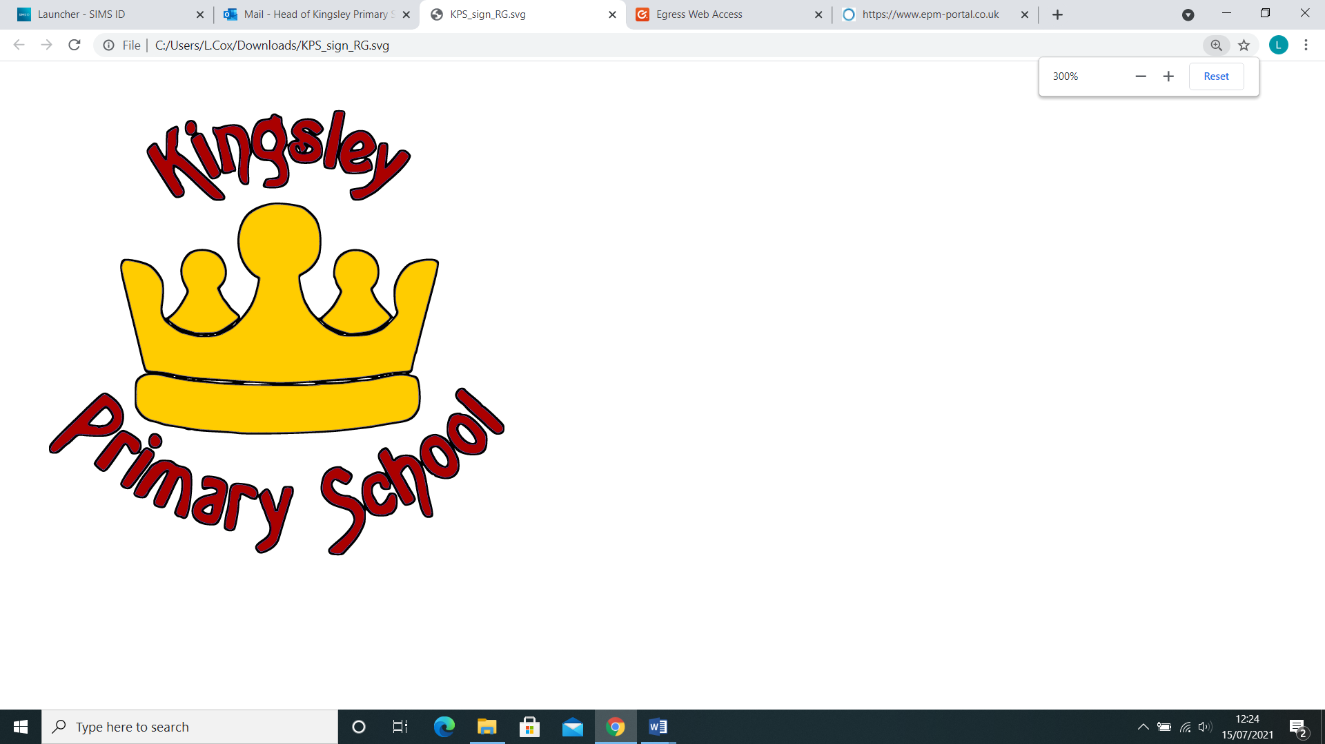

January 2023

Introduction
At Kingsley Primary School, we recognise that the personal development of pupils, spiritually, morally, socially and culturally, plays a vital part in their ability to learn and achieve. Through our values of RAISE and our curriculum driver of FLIGHT, we want our staff to help our pupils grow as a whole. We therefore aim to provide an education that provides pupils with opportunities to explore and develop their own values and beliefs, spiritual awareness, high standards of personal behaviour, a positive, caring attitude towards other people, an understanding of their social and cultural traditions and an appreciation of the diversity and richness of the cultures.
Definitions
Spiritual Development
Pupils’ spiritual development is shown by their:
- beliefs, religious or otherwise, which inform their perspective on life & their interest in & respect for different people’s feelings & values
- sense of enjoyment and fascination in learning about themselves, others and the world around them, including the intangible
- use of imagination and creativity in their learning
- willingness to reflect on their experiences
Moral Development
Pupils’ moral development is shown by their:
- ability to recognise the difference between right and wrong, and their readiness to apply this understanding in their own lives
- understanding of the consequences of their actions
- interest in investigating, and offering reasoned views about, moral and ethical issues
Social Development
Pupils’ social development is shown by their:
- use of a range of social skills in different contexts, including working and socialising with pupils from different religious, ethnic and socio-economic backgrounds
- willingness to participate in a variety of social settings, cooperating well with others and being able to resolve conflicts effectively
- interest in, and understanding of, the way communities and societies function at a variety of levels
Cultural Development
Pupils’ cultural development is shown by their:
- understanding and appreciation of the wide range of cultural influences that have shaped their own heritage
- willingness to participate in, and respond to, for example, artistic, musical, sporting, mathematical, technological, scientific and cultural opportunities
- interest in exploring, understanding of, and respect for cultural diversity and the extent to which they understand, accept, respect and celebrate diversity, as shown by their attitudes towards different religious, ethnic and socio-economic groups in the local, national and global communities
Guidance
- The curriculum has factored in the whole aspect of a child. All curriculum areas have a contribution to make to the child’s spiritual, moral, social and cultural development.
- Growth is one of the key drivers behind the curriculum.
- All adults will model and promote expected behaviour, treating all people as unique and valuable individuals and showing respect for pupils and their families.
- The school community will be a place where pupils can find acceptance for themselves as unique individuals and where forgiveness and the opportunity to start again is fundamental to the ethos of the school.
- Our values are embedded across the school, and pupils are encouraged to respect each our and work together with synergy.
- Pupils should learn to differentiate between right and wrong in as far as their actions affect other people.
- They will be encouraged to value themselves and others.
- Pupils should understand the need for rules and the need to abide by rules for the good of everyone. School and classroom rules should reflect, reiterate, promote and reward acceptable behaviour and provide opportunities to celebrate pupils’ work and achievements.
- All curriculum areas should seek to use illustrations and examples drawn from as wide a range of cultural contexts as possible. This will be reflected in teacher’s planning decisions.
General Aims
- To ensure that everyone connected with the school is aware of our values and principles.
- To ensure a consistent approach to the delivery of SMSC issues through the curriculum and the general life of the school.
- To ensure that a pupil’s education is set within a context that is meaningful and appropriate to their age, aptitude and background.
- To ensure that pupils know what is expected of them and why.
- To give each pupil a range of opportunities to reflect upon and discuss their beliefs, feelings and responses to personal experience.
- To enable pupils to develop an understanding of their individual and group identity.
- To enable pupils to begin to develop an understanding of their social and cultural environment and an appreciation of the many cultures that now enrich our society.
- To give each pupil the opportunity to explore social and moral issues, and develop a sense of social and moral responsibility.
Spiritual Development
As a school, we aim to provide learning opportunities that will enable pupils to:
- sustain their self-esteem in their learning experience;
- have a fully developed RE curriculum which encourages spiritual development for each pupil;
- develop their capacity for critical and independent thought;
- foster their emotional life and express their feelings;
- experience moments of stillness and reflection;
- discuss their beliefs, feelings, values and responses to personal experiences;
- form and maintain worthwhile and satisfying relationships;
- reflect on, consider and celebrate the wonders and mysteries of life.
Moral Development
As a school, we aim to provide learning opportunities that will enable pupils to:
- recognise the unique value of each individual;
- utilise assemblies and lesson time to embed the school values;
- actively promote British Values
- listen and respond appropriately to the views of others;
- gain the confidence to cope with setbacks and learn from mistakes;
- take initiative and act responsibly with consideration for others;
- act swiftly against behaviours that are unkind/immoral
- distinguish between right and wrong;
- show respect for the environment;
- make informed and independent judgements.
Social Development
As a school, we aim to promote opportunities that will enable pupils to:
- work cooperatively as a group;
- promote teamwork and synergy in and across classes;
- engage in the democratic process and participating in community life;
- develop personal qualities which are valued in a civilised society, for example, thoughtfulness, honesty, respect for difference, moral principles, independence, interdependence, self-respect and an awareness of others’ needs;
- work closely alongside other InMAT schools.
Cultural Development
As a school, we aim to promote opportunities that will enable pupils to:
- recognise the value and richness of cultural diversity in Britain, and how these influenced individuals and society;
- positively embrace the many different cultures across the school;
- develop an understanding of their social and cultural environment;
- develop an understanding of Britain’s local, national, European, Commonwealth and global dimensions.
- reflect on important questions of meaning and identity;
- develop an interest in exploring the relationship between human beings and the environment;
- respect racial, religious and other forms of equality.
Teaching and Organisation
Development in SMSC will take place across all curriculum areas, within activities that encourage pupils to recognise the spiritual dimension of their learning, reflect on the significance of what they are learning, and to recognise any challenges that there may be to their own attitude and lifestyle. Please see separate ‘SMSC across the curriculum’ documents.
Assemblies will promote focus on developing our pupils SMSC understanding through covering a range of topics.
All curriculum areas should seek illustrations and examples drawn from as wide a range of cultural contexts as possible.
Class discussions and debates will give pupils opportunities to:
- Talk about personal experiences and feelings.
- Express and clarify their own ideas and beliefs.
- Speak about difficult events, eg bullying, death etc.
- Share thoughts and feelings with other people.
- Explore relationships with friends/family/others.
- Consider others needs and behaviour.
- Show empathy.
- Understand and respect children’s rights.
- Develop self-esteem and a respect for others.
- Develop a sense of belonging.
- Develop the skills and attitudes that enable pupils to develop socially, morally, spiritually and culturally – eg empathy, respect, open mindedness, sensitivity, critical awareness, etc (for comprehensive list see attached sheet).
Many curriculum areas provide opportunities to:
- Listen and talk to each other.
- Learn an awareness of treating all as equals, and accepting people who are physically or mentally different.
- Agree and disagree.
- Take turns and share equipment.
- Allow pupils to view and learn about differing cultures and ways of life
- Work co-operatively and collaboratively.
Links with the wider community
- Visitors are welcomed into school.
- Staff plan educational visits throughout the year.
- The development of a strong home-school link is regarded as very important, enabling parents and teachers to work in an effective partnership to support the pupil.
- Pupils will be taught to appreciate their local environment and to develop a sense of responsibility to it

